**RMI Study Guide: Exam 1**

|  |  |
| --- | --- |
| Types of Variables | |
|  |  |
| Scales of Measurement | |
|  |  |

Measures of central tendency are:_______________________________________________

Measures of variability are:_____________________________________________________

Basic vs. Applied Research:____________________________________________________

Variable vs. Constant:_________________________________________________________

What are the goals of science?__________________________________________________

What is a construct?__________________________________________________________

An operational definition is_____________________________________________________

Modes of measurement:_______________________________________________________

Reliability vs. Validity:_________________________________________________________

Normal distribution vs. Standard Normal distribution_________________________________

Sample vs. Population?_______________________________________________________

Descriptive vs. Inferential Statistics:______________________________________________

What is the Law of Large Numbers?______________________________________________

What is random sampling?_____________________________________________________

What is a z-score and what does it show?_________________________________________

The Nuremberg Trials (1947) gave way to the______________________________________

Name a few unethical studies learned in class:_____________________________________

What are the three basic principles of the Belmont Report (1979)?______________________

Is deception ever allowed in research?­­­­­­­­­­­­­­____________________________________________

Who is governed by IRBs?______________________________________________________

Insert the percentages on the graph below:

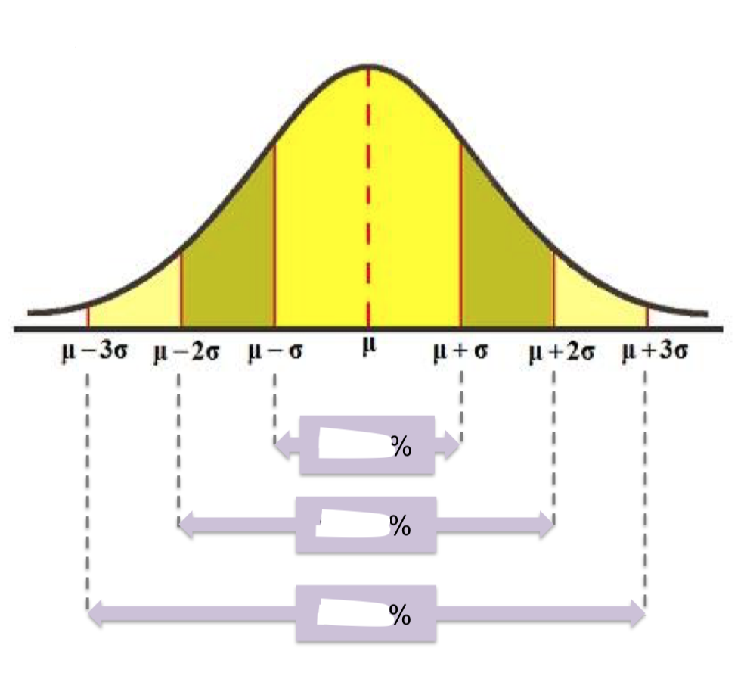

Things to make sure you can do:

Make a Frequency Distribution and know how to plot vs. table

Use Excel to organize data and make a basic graph

How to import data from Excel into JASP

Interpret Excel/JASP output (including frequency tables, tables of descriptives, one samples t-test)

How to make different graphs and know the correct name for each graph

Can calculate measures of central tendency and when to use them based on variable type or other characteristics of the sample data (e.g., when data is skewed)

Can calculate measures of variability by hand, in Excel, and in JASP

Can calculate basic probabilities like the problems worked on in class

Can calculate z-scores and percentiles and apply this to word problems

Know how to use a z table or online z calculator